# User Manual for Smart Lab Assistant

## Who is this Manual for?

This manual is for individuals looking to use the smart lab assistant software when conducting experiments in any of the laboratory rooms. This system is especially handy if the user is working in glove boxes or clean room work that hinder the user’s ability to take notes, operate equipment and look up records.

## Overview of System

The Smart Lab Assistant is a software designed to work with the Plantronics Voyager 3200 Bluetooth Headset. When deployed in a laboratory environment, users can interact with the system through voice only. Examples of the possible use cases of this system include:

* Take notes and records through audio dictation (speech-to-text note taking)
* Interact with machineries in the laboratory (e.g. turning machine on and off)
* Activate embedded software timer (e.g. countdown timer)

## Before Using the System

Please ensure you have the correct version of the software from Michael Rae ([Michael.rae@csiro.au](mailto:Michael.rae@csiro.au)). Michael will also provide the headset, Bluetooth dongle (if required) and also assist in setting up a profile in the system. To set up a voice profile, the user might be required to volunteer certain voice samples, which will subsequently be used to train the system.

## Getting Started

To get started, make sure the Plantronics (Plantronics Voyager 3200 Headset) is turned on and paired with the computer in the laboratory. This manual assumes that the operating system on the laboratory computer is Windows 10. To pair the device to the computer, follow these instructions:

1. For your computer to see the Bluetooth peripheral device, you need to turn it on and set it into pairing mode. It typically involves pressing and holding the Bluetooth button until you see a flashing light that indicates the pairing is ready.
2. For computers without built in Bluetooth capabilities, plug the DIGITECH Bluetooth Smart USB Dongle into any USB 2.0 port on the computer.
3. Then proceed to the Windows Settings app.
4. Navigate to Devices and go to Bluetooth.
5. Make sure the Bluetooth switch is in the “On” position. (You'll know it is working because you'll notice the message that reads "Your PC is searching for and can be discovered by Bluetooth devices.")
6. Select the device you want to connect (Plantronics V3200) and click Pair.
7. If necessary, enter four zeros (0000) for the passcode or accept the connection. Once successfully paired, on the headset you will hear “pairing successful."

## Starting the System

To start the system, click on the executable file “csiro_vlas.exe.” If the executable file starts successfully, the user should see the interface shown in *Figure 1*.

## Activating the System

After starting the software, the virtual lab assistant will have to be activated to understand voice commands. The assistant is activated based on a voice-based trigger word – “Hello CSIRO”, this trigger word activation works similar to “Hey Siri” or “Hey Google” activations for other smart assistants. Once the system has been activated, the user will hear a “ding” sound in the earpiece, after which they can pass in speech-commands.

Note: users who have not had their voice profiles trained on the system might encounter difficulties using the voice-based activation.

## Types of Commands

The types of tasks and example of speech-based commands are shown below:

|  |  |  |  |  |
| --- | --- | --- | --- | --- |
| Function | Voice Command | Parameters | Behaviour | Note |
| Transcribe Notes | * “activate note taking” * “take notes” | None | <trigger word detected>  <transcribe notes command>  <*Bing>  <dictate notes>  <“exit”> | Dictate notes through speech. When dong with note-taking, say ‘exit’ to return from note transcription. |
| Start Timer | * “activate timer” * “countdown for 10 seconds” | duration = {  ‘’amount”: ,  “unit”: } | <trigger word detected>  <start timer command>  <*Bing>  <timer activates in background> | Start a timer or set reminder. When using this function, have to specify the duration (amount, unit) for the timer. |
| Control Lab Machinery | * “turn on lab machine 3” * “what is the status of machine 2” | labMachine = {“”} | <trigger word detected>  <control lab machinery command>  <*Bing>  <activate machinery> | Commands to check machine status or interact with machine (turn on or off). Have to specify the labMachine index in command. |
| Save Files | * “save this note” * “save file” | None | <trigger word detected>  <save file command>  <*Bing>  <saves file> | Saves conversation log and notes taken to the local disk. |
| Status Check | * “is the assistant active” * “is the microphone connected” | None | <trigger word detected>  <status check command>  <*Bing>  <checks and returns status> | Command to check the status of virtual assistant, microphone etc. |

The virtual assistant has built-in conversation-modelling behaviour, so a conversation can be maintained and continued as the user interacts with the system. Also note that the user does not have to repeat the commands exactly but any commands with similar interpretations can be used.

A “ding” sound is played every time a command is successfully recognised. The graphical user interface (GUI) will also be updated to reflect the intent recognised and captured.

## Using the System

After the system starts up, it will continuously listen for the trigger word “Hello CSIRO”. Once the trigger word is detected, the user will hear a “ding” sound in the earpiece, and the activation status on the graphical user interface (GUI) will change to indicate that the assistant has been activated. After activation, the user can command the system to perform any of the tasks listed above through voice-based commands. Once the command has been executed, the system will return to idle mode. The system can be activated once again when the user says the trigger word. When the user has finished his/her work in the lab, say “exit” to save all relevant files and exit the system completely.

A visualised flowchart of this process can be found in *Figure 2*.

## Saving Files

The conversation log and the notes taken are automatically saved to disk when the system exits. The files are stored in the directory (~/Desktop/SavedFile/YYYY-mm-dd_HH-MM.txt). The filename will be the timestamp at which the file is saved. To save files at any time, the user can tell the assistant to “save files.”

## Contact

For technical enquiries, please contact Michael Rae at [Michael.rae@csiro.au](mailto:Michael.rae@csiro.au)

## https://confluence.csiro.au/download/attachments/838829826/GUI.PNG?version=1&modificationDate=1548735550313&api=v2

Figure 1. Graphical User Interface for Smart Lab Assistant

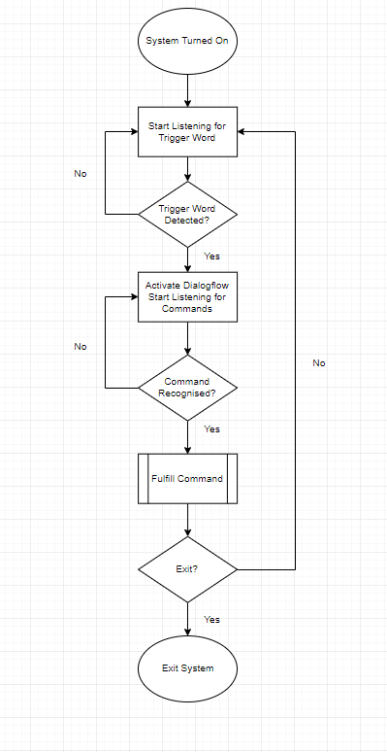

Figure . Process Flowchart